PRESS CLIP
Publication:- The Times of Bengal (http://www.thetimesofbengal.com/the-bengal-chamber-hosts-padma-shri-prof-dr-ashok-gulati-in-his-delivery-of-the-annual-endowment-lecture-on-policies-to-make-indian-peasants-prosperous/ )
Date:- 22nd February, 2019
Page:- Online

The Bengal Chamber hosts Padma Shri Prof (Dr.) Ashok Gulati in his delivery of the Annual Endowment Lecture on policies to make Indian peasants prosperous.
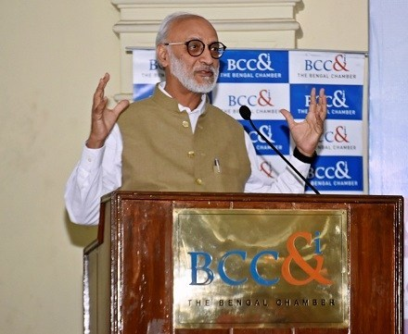

The Bengal Chamber hosts Padma Shri” Prof (Dr.) Ashok Gulati in his delivery of the Annual Endowment Lecture on policies to make Indian peasants prosperous

India is one of the leading countries in having a young employable population And with the majority of the population, residing in villages, the agricultural sector can provide a huge landscape for entrepreneurship, opportunities, skilling, training and lastly contribute to the economy. In an effort to develop our agri based sectors and industries the government both at centre and state are constantly focussing through means and methods to boost the sector through loans, insurance, irrigation facilities, training and skilling of rural youth and also bridging and linking researchers, scientists with the farmers.

To throw light more on the ways and means the government schemes are being devised to help the farming community, the Agriculture & Rural Development Committee, The Bengal Chamber, hostedPadma Shri , Professor (Dr.) Ashok Gulati who delivered the “Professor S B Chattopadhyay Endowment Lecture” on Wednesday, February 20, 2019.
“We are honored to have among us the eminent agricultural economist, Prof(Dr.) Gulati who will be talking on the policies to make Indian peasants prosperous. Prof. Gulati whose original treatises is on various aspects concerning the development of agriculture and agrarian economies in India and other Asian countries and the challenges faced by the farmers. More than a dozen books and numerous papers published in international journals bear testimony to his original thinking and analysis.
We welcome all gathered at Prof. Gulati’s lecture on this cotemporary subject of high national importance and also welcome any exchange of thoughts on the subject at the end of his lecture, stated, Mr. Satyabrata Mukherjee Chairperson, Agriculture & Rural Development Committee, the Bengal Chamber.
Prof. Gulati began by stating that in our country 85% of farmers have small crop area. In West Bengal average land holding is 0.7 hectare .While many believe this to be a shortcoming Dr. Gulati cited the instance of China where production has been very high through small land holdings.
Dr Gulati spoke about how realistic is the Prime Minister’s promise of doubling farmer’s income (DFi) by 2022-23. The P.M. gave a clarion call to DFi at a Kisan rally in Bareilly on February 28th, 2016. No one knew whether it was normal income or real income that he spoke of. But in April, 2016, The Dalwai Committee set up for DFi, confirmed that it is real income with a base year of 2015-16. And the 7 years growth rate required was 10.4% p.a. Sources of farmer’s income is primarily through cultivation, earnings from livestocks, wages and salaries, non family businesses. The average farmer income per month in West Bengal is 7756 rupees per month in West Bengal according to published statistics.
The three most important events that brought about structural changes in Agriculture according to Prof. Gulati is the Green revolution, White revolution and Gene revolution. He also said most of the policies that were framed for framers were focused on increase of production. But he feels the markets cannot be neglected. Also there are problems of storage for the surplus with not enough facilities. Most of the policies are restrictive. The private sectors are not allowed to hold stocks. Also free markets should be allowed. There should be a 50-50 focus on production and market which are two sides of the same coin. The policy reforms should be to augment farmers’ income and change focus from tonnage centric to farmer centric. The focus should be on demand led growth and markets have to be ensured before productivity is raised. Reforms in Agricultural produce market committee should be brought in by allowing private mandis, contract farming, regulating commission and building market infrastructure. Also he feels value chains on lines of AMUL model for milk should be focused on. Also there should be innovation in policies from higher minimum support price or highly subsidized inputs and loans waivers to income or investment policies. Also it’s important to invest in research and development. There should be investment in sustainable agriculture specially taking care of water resource and saving on chemicals, he stated.
“I feel today I see a silver lining as there will be a move from price policy approach to income policy approach. Direct support to farmers is better than loan waivers”, stated Dr. Gulati.
Others present were Dr. Chirantan Chattopadhyay, Vice Chancellor-, Uttar Banga Krishi Viswavidyalaya, Dr. Partha R Dasgupta, Advisor-Emeritus Syngenta Foundation for Sustainable Agriculture, Dr. D.D. Patra , Vice Chancellor-Bidhan Chandra Krishi Viswavidyalaya, Mr. Jayanta Chakraborty, Vice –Chairperson, Agriculture & rural Development Committee, The Bengal Chamber.

